DENSITY BASED TRAFFIC SIGNAL SYSTEM

GROUP MEMEBERS:

1. MAYUR KASWA – 56 – 17U083
2. NIKHIL KEDAR - 59 - 17U127
3. SAURABH KESHARWANI – 60 -17U355
4. ADARSH KHANDELWAL – 61 – 17U102
5. OMKAR KHANDELWAL – 62 – 17U018
6. MOHIT KHEMAWANI - 64- 17U118
7. VIRAJ CHATANE – 74 – 21820100

Abstract:

The project is aimed at designing a density based dynamic traffic signal system where the timing of signal will change automatically on sensing the traffic density at any junction.

Traffic congestion is a severe problem in most cities across the world and therefore it is time to shift more manual mode or fixed timer mode to an automated system with decision making capabilities. Present day traffic signaling system is fixed time based which may render inefficient if one lane is operational than the others. To optimize this problem we have made a framework for an intelligent traffic control system. Sometimes higher traffic density at one side of the junction demands longer green time as compared to standard allotted time We, therefore propose here a mechanism in which the time period of green light and red light is assigned on the basis of the density of the traffic present at that time. This is achieved by using PIR (proximity Infrared sensors). Once the density is calculated, the glowing time of green light is assigned by the help of the microcontroller (Arduino). The sensors which are present on sides of the road will detect the presence of the vehicles and sends the information to the microcontroller where it will decide how long a flank will be open or when to change over the signal lights. In subsequent sections, we have elaborated the procedure of this framework.

PRESENT TRAFFIC SIGNALING SYSTEM:

Under present scenario, traffic control is achieved by the use of a system of hand signs by traffic police personnel, traffic signals, and markings. A comparable and matching education program is needed, through driver-licensing authorities, to assure that those who operate motor vehicles understand the rules of the road and the actions that they are required or advised to take when a particular control device is present. Each traffic control device is governed by standards of design and usage; for example, stop signs always have a red background and are octagonal in shape. Design standards allow the motorist to quickly and consistently perceive the sign in the visual field along the road. Standard use of colors and shape aids in this identification and in deciding on the appropriate course of action.

Under current circumstances, traffic lights are set on in the different directions with fixed time delay, following a particular cycle while switching from one signal to other creating unwanted and wasteful congestion on one lane while the other lanes remain vacant. The system we propose identify the density of traffic on individual lanes and thereby regulate the timing of the signals’ timing. IR trans receivers count the obstructions and provide an idea about the traffic density on a particular lane and feed this response to a controller unit which will make the necessary decisions as and when required.

III. OPERATIONAL MODEL

The model works on the principle of changing delay of Traffic signals based on the number of cars passing through an assign end section of the road. There are four sensors placed at four sides of a four way road which counts the number of cars passing by the area covered by the sensors.

Here we are using IR sensors replacing system to design an intelligent traffic control system. IR sensor contains IR transmitter IR receiver (photodiode) in itself. These IR transmitter and IR receiver will be mounted on same sides of the road at a particular distance. As the vehicle passes through these IR sensors, the IR sensor will detect the vehicle & will send the information to the microcontroller. The microcontroller will count the number of vehicles, and pro glowing time to LED according to the density of vehicles. If the density is higher, LED will glow for higher tim than average or vice versa. The traffic lights are initially running at a fixed delay of 5 seconds, which in turn produces a delay of 20 seconds in the entire process. This entire embedded system is placed at that junction. Microcontroller is interfaced with leds and IR sensors.The total no of IR sensors required are 4 and Led’s 12 Therefore these are connected to any two ports of microcontroller. IR transmitter and receiver pairs, w proximity sensor is used. The output voltage according to distance from an object comparator with a reference set. The reference is set by a variable resistance according to required range of sensing.

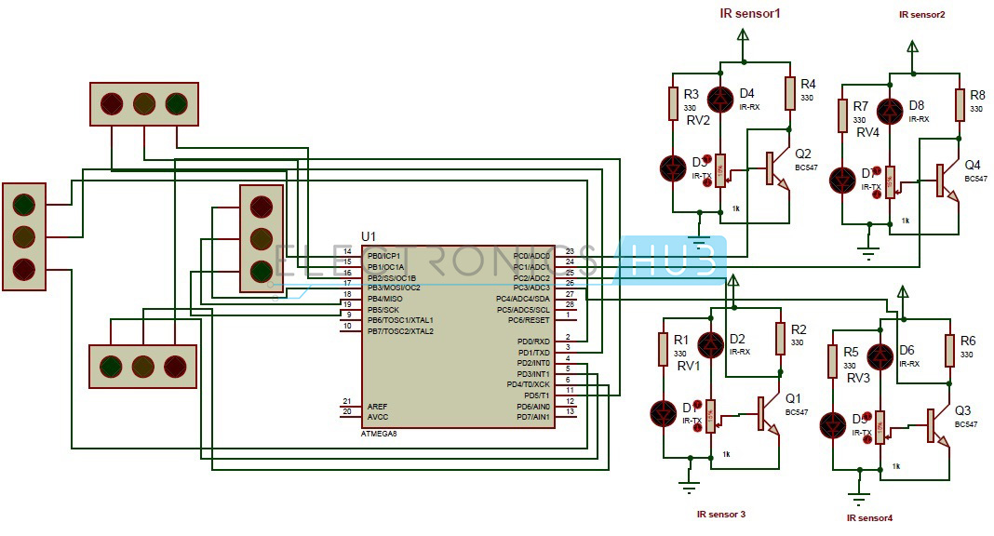

Fig.2: Circuit diagram of sensor module When the sensor finds any object, comparator low else it gives + 5 V (HIGH). The controller program

1: Proposed Model Overview replacing traffic control control system. IR sensor contains IR transmitter IR receiver (photodiode) in itself. These IR transmitter and IR receiver will be mounted on same sides of the road at a particular distance. As the vehicle passes through these IR sensors, l detect the vehicle & will send the information to the microcontroller. The microcontroller will count the number of vehicles, and provide the cording to the density of vehicles. If the density is higher, LED will glow for higher time than average or vice versa. The traffic lights are initially running at a fixed delay of 5 seconds, which in turn produces a delay of 20 seconds in the entire process. This entire embedded system is placed at that junction. s and IR sensors ors required are 4 and Led’s 12. Therefore these are connected to any two ports of

, which work as output voltage that changes

counts this change of events from LOW to HIGH indicating passing of a vehicle. The objective of the IR sensor is to detect obstacles. It comprises an emitter (IR LED), detector (IR photodio and ancillary circuitry. The stronger the reception of IR radiation source, greater is the output voltage. We have used Op – Amp LM324 for the comparator operation where Vin is compared against V ref with the feedback resistance and very high gain. Her connected to +5V and –Vcc the OPAMP output acts as digital HIGH or LOW for the microcontroller.

CODE SECTION:

int R1=10; //pins for RED LEDs

int R2=11;

int R3=12;

int R4=13;

int G1=6; // Pins for Green LEDs and immediate next yellow LEDs

int G2=7;

int G3=8;

int G4=9;

int sensor1=2;

int sensorState1=0;

int lastsensorState1=0;

int CarCounter1=0;

int sensorState2=0;

int sensor2=3;

int lastsensorState2=0;

int CarCounter2=0;

int sensorState3=0;

int sensor3=4;

int lastsensorState3=0;

int CarCounter3=0;

int sensorState4=0;

int sensor4=5;

int lastsensorState4=0;

int CarCounter4=0;

unsigned long previousMillis = 000;

long interval=5000;

void setup() //part that is executed once when the program begin

{

pinMode(G1, OUTPUT);

pinMode(G2, OUTPUT);

pinMode(G3, OUTPUT);

pinMode(G4, OUTPUT);

pinMode(R1, OUTPUT);

pinMode(R2, OUTPUT);

pinMode(R3, OUTPUT);

pinMode(R4, OUTPUT);

digitalWrite(G1, HIGH);

digitalWrite(R3, HIGH);

digitalWrite(R4, HIGH);

Serial.begin(9600); // for serial monitor

}

void loop() // Part that is executed again and again

{ //Counting mechanism for sensor1

sensorState1 = digitalRead(sensor1);

if (sensorState1 != lastsensorState1)

{

if (sensorState1 == HIGH)

{

CarCounter1=1;

}

}

lastsensorState1 = sensorState1;

//Counting mechanism for sensor2

sensorState2 = digitalRead(sensor2);

if (sensorState2 != lastsensorState2)

{

if (sensorState2 == HIGH)

CarCounter2=1;

}

lastsensorState2 = sensorState2;

//Counting mechanism for sensor3

sensorState3 = digitalRead(sensor3);

if (sensorState3 != lastsensorState3)

{

if (sensorState3 == HIGH)

CarCounter3=1;

}

lastsensorState3 = sensorState3;

//Counting mechanism for sensor4

sensorState4 = digitalRead(sensor4);

if (sensorState4 != lastsensorState4)

{

if (sensorState4 == HIGH)

CarCounter4=1;

}

lastsensorState4 = sensorState4;

unsigned long currentMillis = millis(); //Millis function used for creating delay

if (currentMillis - previousMillis>= interval)

{

Serial.print("time :");

Serial.println(previousMillis);

previousMillis = currentMillis;

if(digitalRead(G1)==HIGH)

{

digitalWrite (G2, HIGH);

digitalWrite (G3, LOW);

digitalWrite (G4, LOW);

digitalWrite (G1,LOW);

digitalWrite (R4,HIGH);

digitalWrite (R1,HIGH);

digitalWrite (R2,LOW);

digitalWrite (R3,LOW);

Serial.print ("number of car passed in 2: ");

Serial.println(CarCounter2);

interval= 5000*CarCounter2+5000;

CarCounter2=0;

}

else if(digitalRead(G2)==HIGH)

{

digitalWrite(G3, HIGH);

digitalWrite(G4, LOW);

digitalWrite(G1, LOW);

digitalWrite(G2,LOW);

digitalWrite(R1,HIGH);

digitalWrite(R2,HIGH);

digitalWrite(R3,LOW);

digitalWrite(R4,LOW);

Serial.print("number of car passed in 3: ");

Serial.println(CarCounter3);

interval= 5000*CarCounter3+5000;

CarCounter3=0;

}

else if(digitalRead(G3)==HIGH)

{

digitalWrite(G4, HIGH);

digitalWrite(G1, LOW);

digitalWrite(G2, LOW);

digitalWrite(G3,LOW);

digitalWrite(R2,HIGH);

digitalWrite(R3,HIGH);

digitalWrite(R4,LOW);

digitalWrite(R1,LOW);

Serial.print("number of car passed in 4: ");

Serial.println(CarCounter4);

interval= 5000*CarCounter4+5000;

CarCounter4=0;

}

else if(digitalRead(G4)==HIGH)

{

digitalWrite(G1, HIGH);

digitalWrite(G3, LOW);

digitalWrite(G4,LOW);

digitalWrite(R3,HIGH);

digitalWrite(R4,HIGH);

digitalWrite(R1,LOW);

digitalWrite(R2,LOW);

Serial.print ("number of car passed in 1: ");

Serial.println(CarCounter1);

interval = 5000*CarCounter1+5000;

CarCounter1=0;

}

}

}

**COUNING MECHANISM:**

sensorState1 = digitalRead(sensor1);

if (sensorState1 != lastsensorState1) sensorState1;

{

if (sensorState1 == HIGH) ++CarCounter1;

}

lastsensorState1 = sensorState1;

In the above code section sensorState1 reads and stores the state of sensor1. If the state of the sensor in different from the previous state, it satisfies the condition and only then the statement in parenthesis gets executed. Now again this condition is satisfied both when the sensorState goes high to low or low to high. This may cause the counter to increase two times whenever a car passes, to avoid this problem the counter is increased only when the sensor goes low to high. if (sensorState1 == HIGH) avoid the count when the sensorState goes high to low.

Similarly four counters are used for for sensors for counting cars at four directions. Delay mechanism of the LEDs The delay of LEDs depend on the value of the Counter of each sensor. The function delay() cannot be used as it stops the program till delay is executed and due to this the counters value will not increase for that period of time. To avoid this problem Millis() function is used. Millis function counts milliseconds passed after the program has started.

unsigned long currentMillis = millis();

if (currentMillis - previousMillis>= interval)

{

Serial.print("time :");

Serial.println(previousMillis);

previousMillis = currentMillis;

In the above code section currentMillis stores the milliseconds passed. previousMillis stores the time in milliseconds, the last time the same code was executed, initially its zero. Interval is the delay we want, so if the difference between the last time and the current time is more than the interval then only the code will be executed. Therefore the LED states doesn’t change until the time passed is more than the given interval. Code for glowing LEDs sequentially and according to the counter value of corresponding sections.

if (currentMillis - previousMillis>= interval)

{

Serial.print("time :");

Serial.println(previousMillis);

previousMillis = currentMillis;

if(digitalRead(G1)==HIGH)

{

digitalWrite(G2, HIGH);

digitalWrite(G3, LOW);

digitalWrite(G4, LOW);

digitalWrite(G1,LOW);

digitalWrite(R4,HIGH);

digitalWrite(R1,HIGH);

digitalWrite(R2,LOW);

digitalWrite(R3,LOW);

Serial.print("number of car passed in 2: ");

Serial.println(CarCounter2); interval= 1000*CarCounter2+1000; CarCounter2=0; } else if(digitalRead(G2)==HIGH) } Initially green LED 1 and red LED 3 & 4 are set HIGH, so as the condition if(digitalRead(G1)==HIGH) gets satisfied , it turns the next LED high other LEDs including itself, and G2 LED stays on till time passed is greater than interval. This interval is set according to car counted in each cycle. interval= 1000*CarCounter2+1000. The is 1000 millisecond or 1 sec for each car passing through the sensor and even if no car passes through the sensor the signal will be ON for atleast 1 second. CarCounter is again set to zero, so that fresh count is done till the next round. Similarly after this interval is over if(digitalRead(G2)==HIGH) will be satisfied as G2 LED is ON now and similarly G3 LED will be made ON and others OFF till next interval, and this will go on.

V. CHALLENGES AND FUTURE SCOPE OF ADVANCEMENTS:

Though the prototype model worked very efficiently with remarkable outputs, the real life situation is going to be

way more challenging and demanding. Few of the challenges that should be taken into account are listed as follows

• Low range IR sensors may not be an answer for long range signaling system. We may resort to ultrasound or radar techniques for big scale set-ups.

• Next is the influence of stray signals that may alter the reading of sensor receptors and lead to conveying false information to the microcontroller.

• Periodic checking of the accuracy and precision is a must for efficacious operation of this model prototype. Safety first: it has to be absolutely made sure that no compromise is being made on safety issues, i.e. a secondary stand-by set-upthat can switch over from automated to manual mode, should be provided in case of sensor or circuit malfunctions so that vehicular crowd does not go beyond control. As part of future advancements, the traffic check post may be connected by wireless transmitters by which the crossings ahead may be an anticipation of the traffic that is approaching. This may be achieved the connecting the sensor network with GPS connectivity and short wave radio transmission signals. This will act as a feedforward system making the signaling system even more smooth and congestion free.

VI. CONCLUSION

There is exigent need of efficient traffic management system in our country, as India meets with 384 road accidents every day. To reduce this congestion and unwanted time delay in traffic an advanced system is designed here in this project. With field application of this technology, the maddening chaos of traffic can be effectively channelized by distributing the time slots based on the merit of the vehicle load in certain lanes of multi junction crossing. We have successfully implemented the prototype at laboratory scale with remarkable outcome. The next step forward is to implement this schema is real life scenario for first hand results, before implementing it on the largest scale. We believe that this may bring a revolutionary change in traffic management system on its application in actual field environment.